 | Lyng Primary School Knowledge Organiser  Computing |  | 
Topic: Computing | What is the function of the keyboard? | Year 1 | Summer1


What Goldilocks and Step On words will I use?
Spelling | Defintion
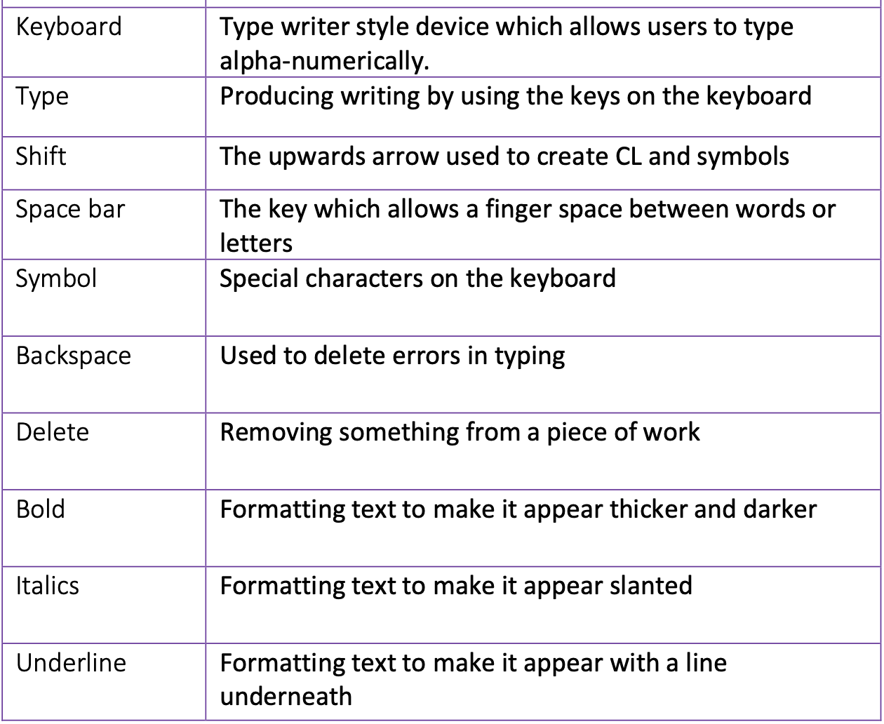
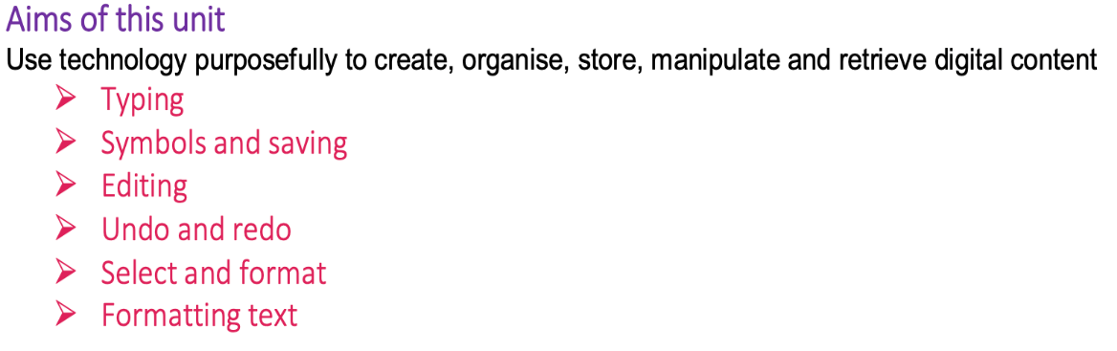
Safeguarding
Filtering and monitoring system is in place. Children will use their own log in details to track any misuse and to protect the child from harmful websites and pop ups. Children will be reminded of how to stay safe online and to use technology safely and respectfully and to tell a trusted adult if there is anything on their computer that makes them uncomfortable.

Outcomes
All children
- Type with two hands
- Use shift, space and enter correctly
- Use undo and redo
- Make text bold, italics or underline

Most children
- Save their work in their folder
- Edit text using backspace, delete and the arrow keys
- Format the font
- Select a single word
Some children
- Have some knowledge of the location of letters and symbols on the keyboard
- Select text in different ways

Autumn Term
Programming using Scratch

In this unit…
Children will learn how to type with two hands, use the shift, space and enter key properly, and edit work by using the backspace, delete and arrow keys. Children will then go on to learn how to use undo and redo and to select and format text.

:

